LEPARAGLIDING lep-3.27+ and lep-3.28

Date 2026-05-02

This summary includes the changes from versions 3.27+ and the new ones in version 3.28.

The small changes version 3.27+:

1) Solved the problem encountered by Paweł with the limitation to 20 holes per rib.

When I programmed the vector that defines the holes I wrote hol(0:100,20,20), which I defined as:
0:100 > 100 ribs per side (total maximum 201 ribs).
20 > up to 20 holes per rib
20 > up to 20 geometric parameters available to define a hole

Now I changed the variable to hol(0:100,200,20), and now we can use up to 200 holes per rib. I did a test with 27 holes, and it works!
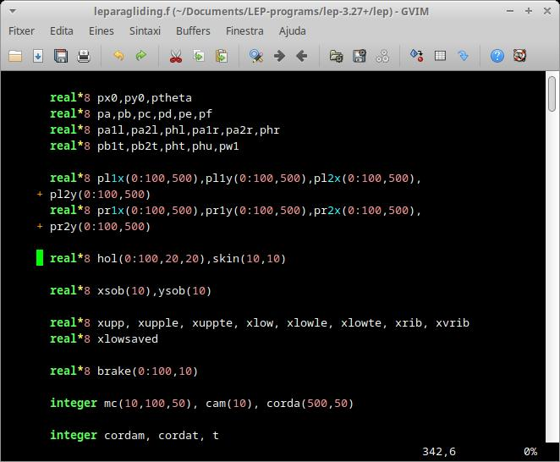

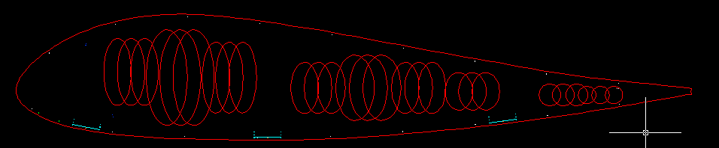
My test using Swoop airfoil (holes still to move and resize).
When doing the above number..., I'm realizing that the limitation on the maximum number of type 6 v-ribs (which you also found), almost certainly comes from the way I defined its vector. By default, I have set maximum100 ribs per side + the rib "0", this makes exactly 100 + 1 + 100 = 201 ribs. I think that resizing the vector that controls the V-ribs, will automatically solve the problem you found. I can define 1000 ribs to be sure! :-) I haven't incorporated this yet...

2) A small utility, in section 37.

This section is a wildcard to add general parameters at will. It consists of an arbitrary code and then one or more parameters that define something.

I simply added the optional parameter "2000" which means, then add a date in text format, for example 2026-01-28
or "December 28, 2026", which serves to remember the date the project was last saved.

Example:

*******************************************************
* 37. SOME SPECIAL PARAMETERS
*******************************************************
1
2
1341 1 use CAD colors for each line type according table 34
2000 2026-01-28

If the optional code 2000 is present, the date is printed in the leparagliding.txt and lep-out.txt files:
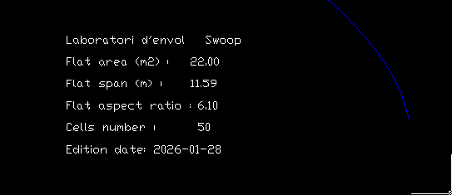

4) In this version, I have started working on the rounded wingtip with a parabola, but only draw in planform, not redesign the panels yet :( Read more: https://laboratoridenvol.com/leparagliding/dev/lep-dev.en.html

Following the proposals of some designers, we are adding the possibility of rounding the wingtip cell. We propose a modification called type "2", which fits a generic degree parabola to the wing tip.
The rear part of the profile remains rectilinear. Starting from a certain point defined at a distance d from the leading edge, a parabola is initiated and ends at the rib located most towards the center.
We have two parameters to control the shape of the parabola, the distance d indicated before, and the angle of tangency with the leading edge. If angle 0.0 is indicated, the program automatically calculates the parabola so that it is tangent to the leading edge. But any other angle of choice can also be defined.
The data group for this type 2 is almost identical to type 1, very simple and looks like this example:
Example, special wingtip type 2:

*******************************************************
* 27. SPECIAL WING TIP
*******************************************************
2
Distance 60.
Angle 0.
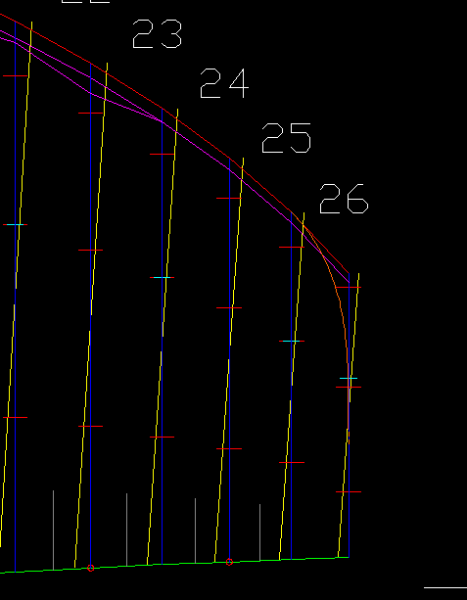

Still not working... :-( But also preparing the same for the trailing edge... :-) This change is not immediate as a new method for developing the wingtip panel must be invented... :-)
Additional changes in version 3.28:

5) Code 3001 used for mini-rib transitions

In section 37 add the special code "3001" meaning minirib transitions. Serves to add a thickness transition to the miniribs, that is, to progressively and smoothly adapt the thickness of the minirib to that of the ovalized profile (non-existent) in the central area of ​​each panel. It is very simple to use, you just need to write 4 numbers.

3001 parameters format:
integer1 integer2 real1 real2
integer1: 3001 (special code)
integer2: can take the values ​​0,1,2, or 3; 0 means not to make any transition, the result is the same as not activating code 3001; 1 means to make a linear transition in a distance "S" with a maximum thickness variation "t" up to zero, according to the attached drawing; 2 means to make a double parabolic transition according to the attached figure (case not yet available); 3 means to make a smooth transition with a cosine type function according to the attached drawing, I recommend always using this case.
real1: It indicates the length of the transition in % of the length of the profile chord. It is the parameter "s" in the figure below.
real2: It indicates the amplification coefficient on the thickness "t" calculated automatically by the program. "t" is the difference in thickness between the ovalized profile and the minirib profile. Normally we will use the value 1.0. If we use 0.0 it is equivalent to not making any type of transition.
Example:

*******************************************************
* 37. SOME SPECIAL PARAMETERS
*******************************************************
1 < use special parameters
1 < use one special parameter
3001 3 6.0 1.0 < use minirib transitipus type

Interpretation figure for sinusoidal (=cosinuidal) transition:

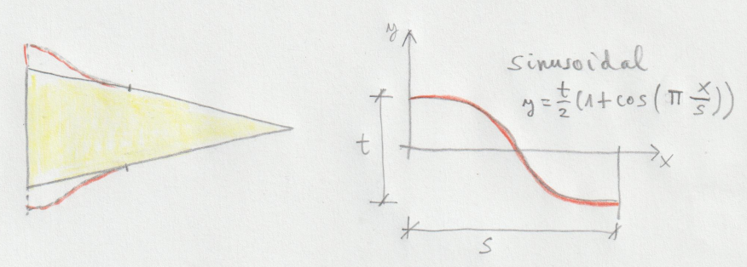

Full figure interpretation cases 1,2,3 and problem description:
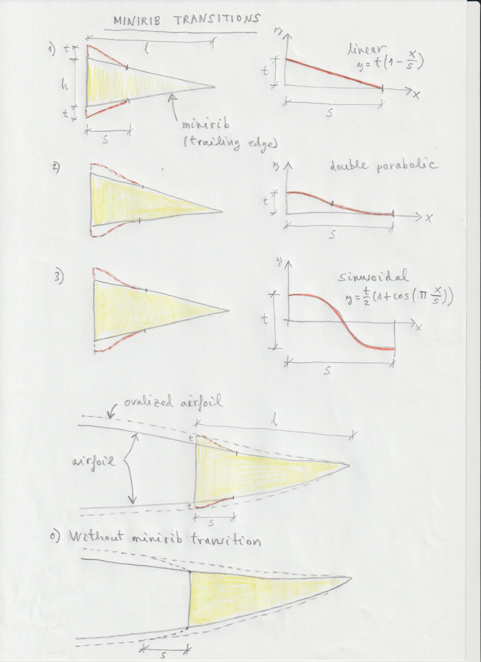
6) Joncs type 3 (shark none)

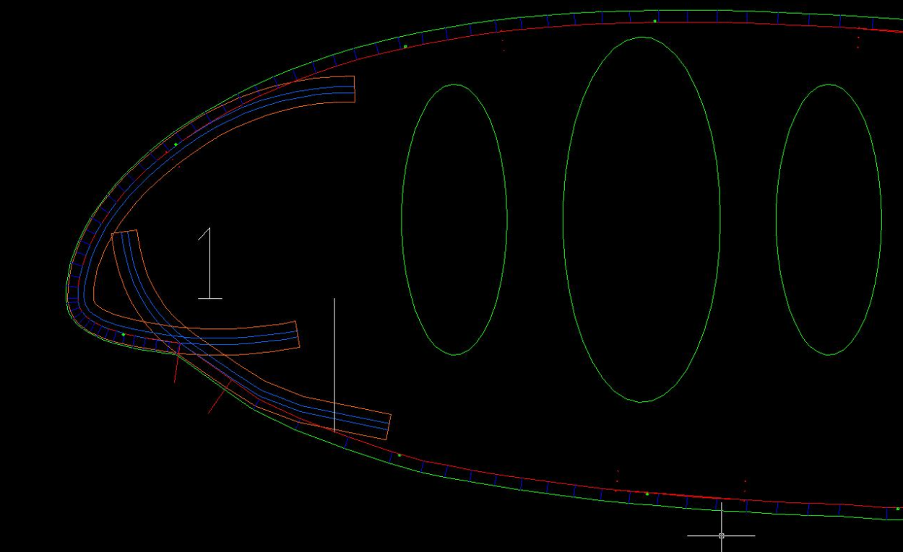

In section 21, to use type rods type "3" (shark nose type using two rods, upper and lower), first of all it is necessary to define a header corresponding to the generic type "2" schema which is the one that allows the most possibilities.

For example, we will start by writing the simplest header using 5 lines, corresponding to a single block with type 3 rods, and only one group for the entire wing:
*******************************************************
* 21. JONCS DEFINITION (NYLON RODS)
*******************************************************
2 < scheme 2
1 < one bloc
1 3 < first bloc type 3 "shark nose"
1 < one group
1 1 30 < first group group from rib 1 to 30

Then write consecutively the following lines:
Line 6: real1 real2 real3 real4 (same as defined in rod type 1)
real1: extrados init point deflection in % of chord
real2: extrados final point deflection in % of chord
real3: value of max deflection in intrados % of chord
real4: value n of exponent in curve of deflection type y=k·x^n (normaly use n=2.0, parabolic)
Line 7: real1 real2 real3 real4
real1: bottom part of upper rod init point deflection in % of chord
real2: parabolic deflection length in % of chord
real3: value of max deflection in % of chord
real4: value n of exponent in curve of deflection type y=k·x^n (normaly use n=2.0, parabolic)
Line 8: real1 real2 real3 real4
real1: upper part of lower rod init point deflection in % of chord
real2: parabolic deflection length in % of chord
real3: value of max deflection in % of chord
real4: value n of exponent in curve of deflection type y=k·x^n (normaly use n=2.0, parabolic)
Line 9: real1 real2 real3 real4 (same as defined in rod type 1)
real1: intrados init point deflection in % of chord
real2: intrados final point deflection in % of chord
real3: value of max deflection in intrados % of chord
real4: value n of exponent in curve of deflection type y=k·x^n (normaly use n=2.0, parabolic)
Line 10: real1 real2 real3 real4 (same as defined in rod type 1)
real1: line 1, offset (mm) defining the rod (see figure)
real2: line 2, external width of pocket (mm)
real3: line 3, width for rod between sewing lines (mm)
real4: line 4, internal width of pocket (mm)
Full example:

*******************************************************
* 21. JONCS DEFINITION (NYLON RODS)
*******************************************************
2 < use scheme 2
1 < one bloc
1 3 < first bloc using type 3 "shark nose"
1 < one group
1 1 30 < first group group from rib 1 to 30
4.2 10.8 1.0 2.0 < coordinates (x1,y1) (x2,y2) and deflection all in % of chord
3.5 5.0 1.0 0.7 < upper rod initial point % of parabolic modification, length, deflection, exponent
4.5 5.0 2.2 1.0 < lower rod initial point % of parabolic modification, length, deflection, exponent
3.67 12.1 0.79 2.0 < coordinates (x1,y1) (x2,y2) and deflection all in % of chord
0.0 10.35 6.3 9.35 < rod pocket sizes in mm
Parameters interpretation:
xeini extrados deflection initial point %
xefin extrados deflection final point %
ye extrados deflection %
ne extrados exponent parabolic deflection
xsne extrados rod (lower part) init of deflection %
ae deflection length %
be deflection %
nsne parabolic exponent
xsni intrados rod (upper part) init of deflection %
ai deflection length %
bi deflection %
nsni parabolic exponent
xiini intrados deflection initial point %
xifin intrados deflection final point %
yi intrados deflection length %
ni intrados exponent parabolic deflection
s1 offset (mm) defining the rod (see figure rod type "1")
s2 external width of pocket (mm)
s3 width for rod between sewing lines (mm)
s4 internal width of pocket (mm)

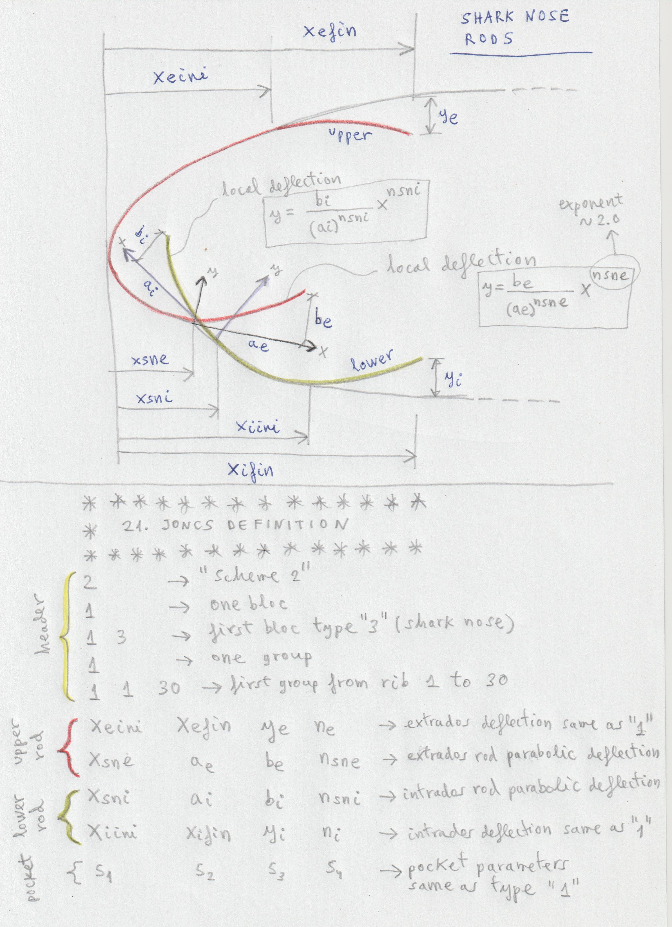
9) Section 32, added three new parameters to control the separation of the rod pockets in the drawing box (1,7)

jonc_x > multiplier coefficient for horizontal separation
jonc_y > multiplier coefficient for vertical separation
jonc_i > multiplier coefficient for vertical separation between the two rods type "3" (shark nose)

Example:

*******************************************************
* 32. PARAMETERS FOR PARTS SEPARATION
*******************************************************
1
panel_x 1.2
panel_x_min 1.0
panel_y 0.8
rib_x 0.8
rib_y 1.0
rib_1y 1.8
jonc_x 0.8
jonc_y 1.0
jonc_i 0.25
parameter10 1.0

10) New output file "run-log.txt"

Generated by default. Contains a record of the same that is printed to the console when the program is executed. It can be useful to detect at which section the reading of the data stops if data is not in the expected format. Using Linux or a Cywin console on Windows, this file is not necessary since the result is displayed in the console.

11) I have also taken note of the other developments to be made (colors, an extra level of ramification lines, rounded wingtips,...) and we will soon be incorporating them... :)

Download lep-3.28 including gnuC2-27 example here:

https://laboratoridenvol.com/leparagliding/leparagliding.en.html#downloads

